**Network &Information Security (CT-460) __ Lab Session 06**

|  |
| --- |
| **Lab Session 6** |

**OBJECT: Folder Security Implementation Through BATCH Programming THEORY**

In DOS, OS/2, and Microsoft Windows, a batch file is a text file containing a series of commands intended to be executed by the command interpreter. When a batch file is run, the shell program (usually COMMAND.COM or cmd.exe) reads the file and executes its commands, normally line-by-line. Batch files are useful for running a sequence of executables automatically and are often used by system administrators to automate tedious processes.

DOS batch files have the filename extension .bat (or .BAT because file names are case insensitive in DOS, Windows and OS/2). There are a number of subtle differences between the .bat and .cmd extensions which affect the error levels returned, among other things; it is a common myth that .bat are run by COMMAND.COM while .cmd are run by CMD.EXE - this is not true and is not the reason for the differences. Also, the Windows 9x family only recognizes the .bat extension.

In this lab session we are going to implement folder security through Batch Programming **PROCEDURE**

1. Create a New Folder and named it “test”.

2. Move your files that you want to secure in to that folder.

3. Write the following script in a notepad to secure your folder and save it with the name “LOCK.bat”

**@echo off**

**echo \*\*\*\*\*\*\*\*\*\*\*\*\*\*\*\*\*\*\*\*\*\*\*\*\*\*\*\*\*\*\*\***

**echo *** Securing ....... Folder \*\*\***

**echo \*\*\*\*\*\*\*\*\*\*\*\*\*\*\*\*\*\*\*\*\*\*\*\*\*\*\*\*\*\*\*\***

**set /p folder= Which Folder ?**

**ren %folder% %folder.{20D04FE0-3AEA-1069-A2D8-08002B30309D} echo Done**

Department of Software Engineering

NED University of Engineering & Technology

Page **62** of **75**

**Network &Information Security (CT-460) __ Lab Session 06**

4. Write the following script in a notepad to UN-Lock your folder and save it with the name “UNLOCK.bat”

**@echo off**

**set /p folder= Which Folder To be UnLock ?**

**ren %folder%.{20D04FE0-3AEA-1069-A2D8-08002B30309D} test**

|  |
| --- |
|  |

Department of Software Engineering

NED University of Engineering & Technology

Page **63** of **75**

**Network &Information Security (CT-460) __ Lab Session 06**

**5.** Now Double Click on LOCK.bat file

|  |
| --- |
|  |

6. Write the Name of folder that you want to secure. In our scenario it is “test” and then press Enter.

|  |
| --- |
|  |

Department of Software Engineering

NED University of Engineering & Technology

Page **64** of **75**

**Network &Information Security (CT-460) __ Lab Session 06**

**7.** After pressing enter your test folder is renamed as folder and representation is converted in to MY Computer.

|  |
| --- |
|  |

.

8. If you double click on “Folder” it directly open My Computer .Means the files that you put in test folder are not accessible and are being secure.

9. To retrieve your test folder double click on Unlock.bat file

Department of Software Engineering

NED University of Engineering & Technology

Page **65** of **75**

**Network &Information Security (CT-460) __ Lab Session 01**

|  |
| --- |
|  |

10. Write the name of folder like in our scenario is “Folder” and then press Enter.

|  |
| --- |
|  |

Department of Software Engineering

NED University of Engineering & Technology

Page **66** of **75**

**Network &Information Security (CT-460) __ Lab Session 06**

NED University of Engineering & Technology

Page **67** of **75**

**EXERCISE**

**4. In the DOS Batch Programming what does @ECHO OFF means**

In DOS Batch Programming, @ECHO OFF is used to control how commands are displayed in the command prompt when a batch file is executed.

**ECHO:** This command toggles the display of commands in the command prompt.

**OFF:** This setting prevents the commands from being shown as they run.

**@:** This symbol before the command suppresses the display of the ECHO OFF command itself.

So, when we include @ECHO OFF at the beginning of a batch file, it means:

Commands will not be displayed in the command prompt, making the output cleaner.

The ECHO OFF command itself will not be shown, so the first visible output will be from subsequent commands.

**5. What command you use to take input in Batch Programming**

In Batch Programming, you use the **SET** command to take input from the user. The most common way to prompt for user input is to combine **SET** with the /P option.

**Command**

**SET /P variable_name=prompt_message**

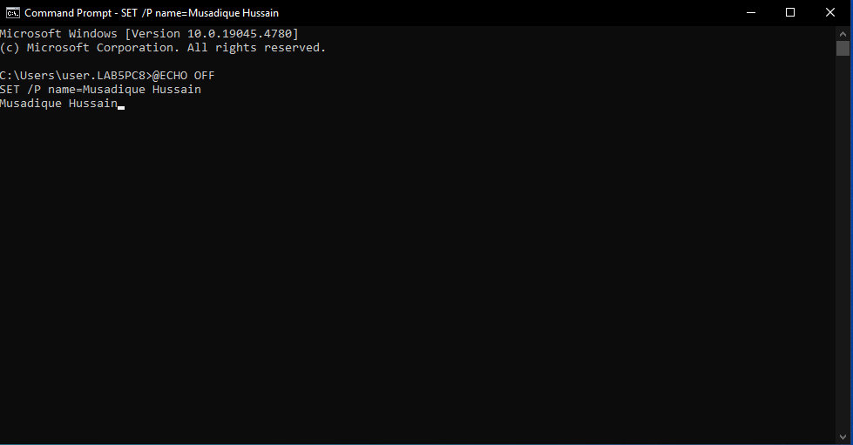

**ECHO OFF:** Hides command output for a cleaner display.

**SET /P name=Please enter your name::** Prompts the user to enter their name, storing the input in the variable name.

**ECHO Hello, %name%!:** Outputs a greeting that includes the user’s input.

**6. Write the command to rename NED.bat file to BCIT.bat file.**



